Chapter 03 Exercises
Student ID: 11204604 Name: Tse Wen Hong

- Stock prices for AllElectronics and HighTech
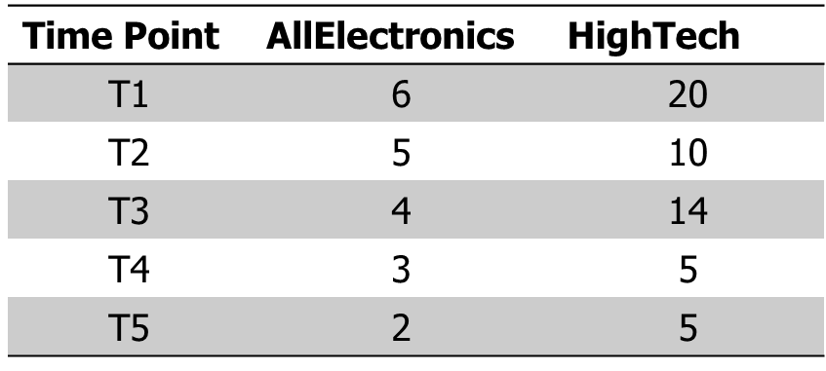
- If the stocks are affected by the same industry trends, will their prices rise or fall together? [ Yes]
- Pearson correlation = ? [ 0.867 ]

- Suppose a group of 12 sales price records has been sorted as follows:
5, 10, 11, 13, 15, 35, 50, 55, 72, 92, 204, 215.
Partition them into three bins by each of the following methods.
(a) equal-frequency (equal-depth) partitioning
bin1：5、10、11、13
bin2：15、35、50、55
bin3：72、92、204、215
(b) equal-width partitioning
bin1：5、10、11、13、15、35、50、55、72
bin2：92
bin3：204、215
(c) min-max normalization by setting min=0 and max=1
bin1：5、10、11、13、15、35、50、55、72
bin2：92
bin3：204、215

[Calculation]

